Rainbow Writing  Rainbow write your sight words.  where | Tactile Writing  Write your words with shaving cream, sand, salt, or something else. | Lowercase vs. Uppercase  Write your words in all lowercase, then all uppercase.  Ex:  DO do  HELLO hello | Alphabetical Order  Write your words in alphabetical order.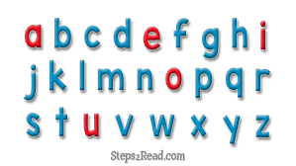
Pyramid Words  Write your words in pyramid style.  Ex:  h  ha  hav  have | Word Typing  Type your words on the computer. Read each word aloud after you type it.  Print your words if you want a study sheet. | Syllable Samurai  Write your word with it broken up into syllables.  Ex:  under  /un/ /der/ | Memory  Using notecards or square-cut paper, write each sight word on two cards. Use it to play memory with a partner.
Sentence Writing/Dictation  Write (or at the beginning of the year, say aloud) a sentence using your sight words.  Ex:  big  The big cats are at the zoo! | Dance Break  Watch 2 Jan Richardson videos on tricky words. | Invisible Words  On white paper, write your words in white crayon. Use a marker to color over the paper and find your invisible words. | Race Yourself  Pick 5 challenging sight words. With an adult timing you, write each word as many times as you can in a minute.
Lightning Round  Make flashcards with your sight words. Practice them with an adult. | Consonants vs. Syllables  Write your sight words with the consonants in blue and the vowels in red.  Ex:  cat  cat | Get Crafty  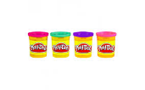  Use playdough to create your words.  or  Write your words in bubble letters and decorate them. | Word Detective  Use a magazine or newspaper and highlight any sight words you find.

